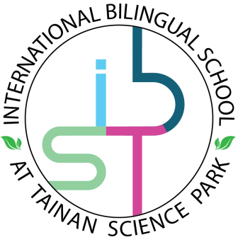

**I**nternational

**S**chool

**Daily Lesson Plan**

**B**ilingual

at **T**ainan Science Park

**Teacher: Date:**

|  |  |
| --- | --- |
| Class Title | Grade Level |
|  |  |
| Common Core Curriculum Standards Covered | |
|  | |
| Learning Objectives | |
|  | |
| Essential Vocabulary/Learning Activities | |
|  | |
| Assessments(Formative and/or Summative) | |
|  | |
| Vocabulary, Materials, Resources (needed by teacher and students) | |
|  | |
| Reflection | |
|  | |
| Comments/Notes: | |
|  | |